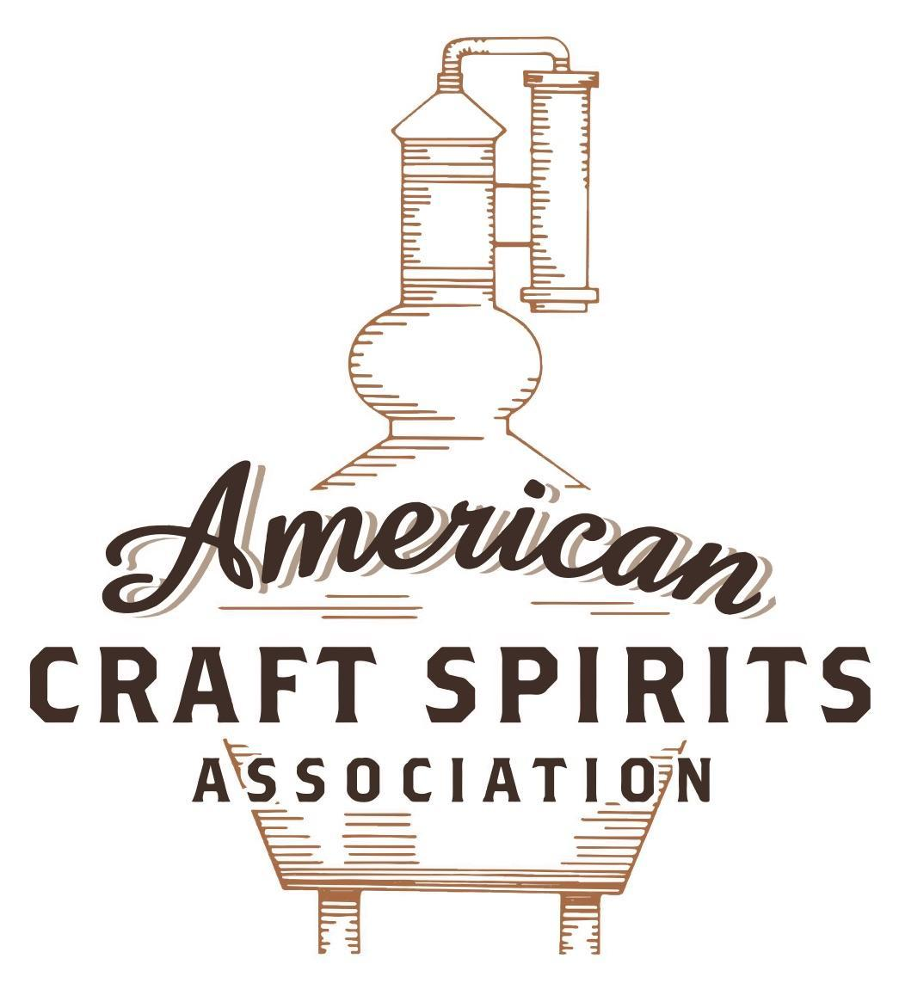
Spirits DtC Shipping Guide

This guide summarizes the direct-to-consumer shipping rules for distilleries in all 50 states and D.C. and also addresses the measures state governments have taken to ease delivery and shipping restrictions during the COVID-19 pandemic.

DtC Quick Guide Comparison

Out-of-State Distilleries  Can Ship Into State? |  |  |  | In-State Distilleries  Can Ship Within State?
State | Yes | No |  | State | Yes | No
AL |  | X |  | AL |  | X
AK | X |  |  | AK | X
AZ | X |  |  | AZ | X
AR |  | X |  | AR |  | X
CA |  | X* |  | CA |  | X*
CO |  | X |  | CO |  | X
CT |  | X* |  | CT |  | X
DE |  | X |  | DE |  | X
DC | X |  |  | DC | X
FL |  | X |  | FL |  | X
GA |  | X |  | GA |  | X
HI |  | X* |  | HI |  | ?*
ID |  | X |  | ID |  | X
IL |  | X* |  | IL |  | X*
IN |  | X |  | IN |  | X
IA |  | X* |  | IA |  | X*
KS |  | X |  | KS |  | X
KY | X |  |  | KY | X
LA |  | X |  | LA |  | X
ME |  | X* |  | ME |  | X*
MD |  | X |  | MD |  | X
MA |  | X |  | MA |  | X
MI |  | X |  | MI |  | X
MN |  | X |  | MN |  | X
MS |  | X |  | MS |  | X
MO |  | X |  | MO |  | X
MT |  | X |  | MT |  | X
NE | X |  |  | NE | X
NV |  | X* |  | NV |  | X
NH | X |  |  | NH |  | X*
NJ |  | X* |  | NJ |  | X*
NM |  | X |  | NM |  | X
NY |  | X* |  | NY |  | X*
NC |  | X |  | NC |  | X
ND | X |  |  | ND | X
OH |  | X |  | OH |  | X
OK |  | X |  | OK |  | X
OR |  | X |  | OR | X
PA |  | X* |  | PA |  | X
RI |  | X* |  | RI |  | X
SC |  | X |  | SC |  | X
SD |  | X |  | SD |  | X
TN |  | X |  | TN |  | X
TX |  | X |  | TX |  | X
UT |  | X |  | UT |  | X
VT |  | X |  | VT |  | X
VA |  | X |  | VA |  | X
WA |  | X* |  | WA | X
WV |  | X* |  | WV |  | X*

WI |  | X |  | WI |  | X
WY |  | X |  | WY |  | X

Notes:
*CA: If passed and signed into law, Senate Bill 620 would allow licensed distilled spirits producers in states other than California and licensed distilled spirits manufacturers or craft distillers in California who obtain distilled spirits direct shipper permits to ship directly to consumers in California
*CT: Consumers with appropriate permit may receive alcohol shipments
*HI: Consumers with appropriate permit may receive alcohol shipments; If passed and signed into law, Senate Bill 65 would allow licensed distilled spirits manufacturers in Hawaii and in states other than Hawaii who obtain direct shipper permits to ship directly to consumers in Hawaii
*IL: If passed and signed into law, Senate Bill 0532 would allow licensed distilled spirits producers in Illinois and in states other than Illinois who obtain distillery shippers’ licenses to ship directly to consumers in Illinois
*IA: If passed and signed into law, House File 639 would allow native distilled spirits manufacturers in Iowa and in states other than Iowa who obtain direct shipper permits to ship directly to consumers in Iowa and to consumers in states other than Iowa
*ME: If passed and signed into law, Legislative Document 1358 would allow distilleries outside of Maine with current manufacturer licenses and distilleries licensed in Maine who obtain spirits direct shipper licenses to ship directly to consumers in Maine
*NJ: (1) If passed and signed into law, Assembly Bill 3167 would allow a craft distillery licensees to ship no more than 9 liters of distilled spirits to a consumer in New Jersey; (2) If passed and signed into law, Senate Bill 3020 would allow craft distillery licensees in New Jersey or in states other than New Jersey to ship no more than 20 liters of distilled spirits to a consumer in New Jersey via common carrier
*NV: Licensed individuals can import one gallon per month of spirits for personal use and the out-of-state supplier must pay excise tax
*NH: If passed and signed into law, Senate Bill 125 would allow licensed liquor manufacturers who obtain direct to consumer shipping permits from the commission to ship directly to consumers in New Hampshire
*NY: Consumer may import up to 90L of liquor per year for personal use without a license; If passed and signed into law, Assembly Bill 3275 would allow licensed liquor manufacturers in states other than New York and licensed distillers and farm distillers in New York to ship no more than thirty-six cases (no more than nine liters per case) of liquor to consumers in New York
*PA: Consumer may place a special liquor order and distiller must ship to a PLCB-operated store
*RI: Distiller can only ship to customer if order was personally placed by customer at distiller's premises
*WA: If passed and signed into law, House Bill 1432 would allow licensed spirits manufacturers in states other than Washington to ship spirits to consumers in Washington
*WV: Distilleries, mini-distilleries, or micro-distilleries licensed in West Virginia or a state other than West Virginia who obtain private direct shipper licenses to ship to a consumer in West Virginia, however the shipments must be made to a retail liquor outlet

SOUTH DAKOTA
Shipment Outbound – Silent.
Shipment Inbound – No, direct shipping licenses are only provided to wineries.
Shipment Intra-state – No, artisan distillers and licensed distillers can sell directly to consumers for on or off-premises consumption at their licensed premises (SDCL § 35-13-19; § 35-13-22).
COVID-19 Measures – No special measures are in place regarding delivery or shipping for distilleries during this pandemic. An FAQ page only clarifies that Artisan Distiller Licensees (AD) may sell alcohol at their licensed premises for off-premises consumption, however, that has always been the case.
Link: https://www.sdra.org/covid-19-business-qa.html
Citation (shipment)
South Dakota Codified Laws
§ 35-13-19. Permitted sales by artisan distiller--Limitation.
A licensed artisan distiller may sell on the licensed premises alcoholic beverages produced by the licensee for on-sale or off-sale consumption. A licensed artisan distiller may sell alcoholic beverages produced by the licensee to any wholesaler or retailer authorized to receive the alcoholic beverages. A licensed artisan distiller may sell alcoholic beverages to any licensed artisan distiller, farm winery, microbrewery, or microcidery, if the alcoholic beverage is used in the manufacturing process.
The quantity of alcoholic beverages sold pursuant to this section may not exceed the total production limits for the license as specified in § 35-13-13.
Link: https://sdlegislature.gov/Statutes/Codified_Laws/2059171
§ 35-13-22. Permitted sales by distiller.
A licensed distiller may sell on the licensed premises alcoholic beverages produced by the licensee for on-sale or off-sale consumption. A licensed distiller may sell alcoholic beverages produced by the licensee to any wholesaler authorized to receive the alcoholic beverages.
Link: https://sdlegislature.gov/Statutes/Codified_Laws/2059174

The American Craft Spirits Association (ACSA) is working diligently to give our members and industry partners relevant, current updates on statutes and regulations impacting production, sale and distribution of spirits. With the declaration of the novel coronavirus (COVID-19) in early 2020, many states have issued temporary policy changes or longer-term modernization of alcohol beverage laws. State statutes, regulations created by the state alcohol regulatory authority, as well as any other relevant guidance provided by such authorities (such as advisories, opinions, bulletins, etc.) were reviewed in creation of this document. No city or county ordinances were reviewed. Distillers should be aware that even in states where direct shipping is permissible, always remember to avoid shipping to dry counties. Please consult with your state guild or alcohol beverage authority for the most up-to-date information. This content is intended for educational and informational purposes only. ACSA's pro bono law firm of Malkin Law P.A. provided the core content found in this comprehensive overview of the spirits distribution after COVID-19. It was completed in August 2021 and will be updated regularly. If you have updates you would like to provide, please send to legislation@americancraftspirits.org or directly to the law firm at: ryan@malkin.law / malkin.law. Thank you.

